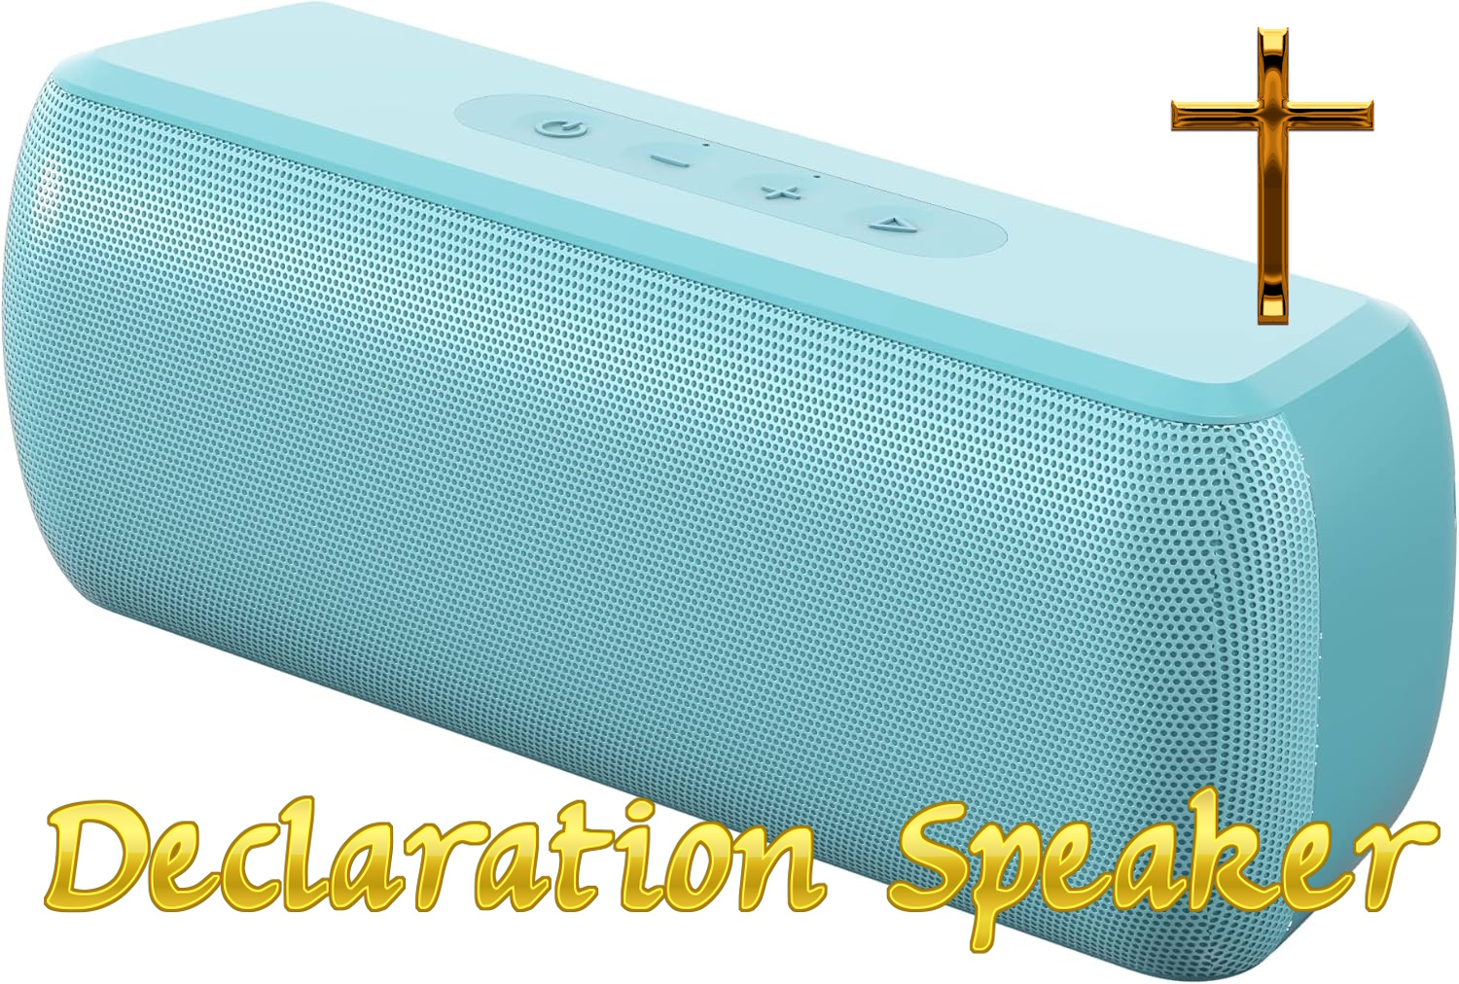
60+ Hours of Bible Promises, Prayer Declarations, Scripture Confessions, Proverbs, Psalms, Intercession, Healing Verses, Worship, and Kingdom Decrees.

Designed to play 24 hours 7 days a week, filling your house
with God’s Word, Worship, Promises, Declarations and Presence.
"Faith comes by hearing, and hearing by the Word of God."
Romans 10:17
Bible Promises & Decrees:
Continually declare who you are in Christ. Let the Kingdom Decrees and Scripture Confessions strengthen your spirit and renew your mind all day long. Proclaim God’s will and His Kingdom on Earth.
Proverbs & Psalms:
Immerse yourself in timeless wisdom and unceasing praise. Let the soothing reading of the Psalms bring peace that transcends all understanding to your heart. Hear the scriptures continually.
Healing Verses:
Faith comes by hearing. Let His promises of restoration wash over you, building your faith to receive the physical and spiritual healing Jesus purchased for you. Claim all of God’s wonderful promises.
Worship Room:
Invite the Holy Spirit into every room. Create an environment of continuous worship and non-stop intercession that aligns your home with the atmosphere of heaven.

Device Setup & Instruction
- Plug & Play: The speaker will instantly play once the included High Speed 16GB Micro SD Card or USB Flash drive is inserted.
- Continuous Devotion: Connect the Fast Charging Adapter to run the speaker continuously. Leave it playing 24/7 to keep your sanctuary filled. This Charger has 2 ports so you can charge another device.
- Bluetooth Ready: Along with pristine HiFi clarity, this speaker is powerful and loud enough for streaming Bluetooth Worship music from your phone if desired. To connect your phone via Bluetooth, tap the power button which will enter Bluetooth Pairing Mode. Long press the power button to turn on and off speaker.
"The grass withereth, the flower fadeth: but the word of our God shall stand for ever." — Isaiah 40:8
For complete information go to: https://GoJes.us/Speaker

